

DEPARTMENT OF INFORMATION TECHNOLOGY
24ITT32 - PROGRAMMING IN JAVA

JAVA JDBC CONNECTION PROJECT
FOR
KEC ACADEMIX MANAGEMENT SYSTEM

PROJECT REPORT
Submitted by
VIKNESHWARAN N
25ITR173
AIM:
Development of Kongu Engineering College (R2024) Student Academic & Continuous Evaluation System using Java JDBC and MySQL.
OBJECTIVE:
Design and develop a database-driven Java application using JDBC to manage student records, perform insert, select, update and delete operations, record incremental marks (Continuous Internal Assessments and End Semester Examinations), enforce attendance eligibility rules, and generate marksheets and academic performance reports according to Kongu Engineering College (Autonomous) - Regulation 2024.
FLOW CHART:
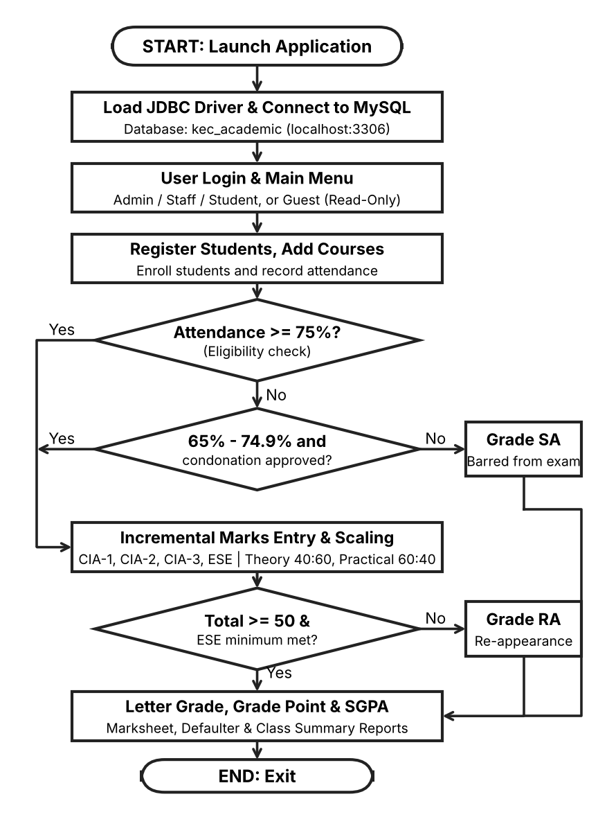
PROCEDURE:
❖ Load the MySQL Connector/J driver (com.mysql.cj.jdbc.Driver) to enable communication between the Java application and the MySQL database.
❖ Establish a connection to the kec_academic database on the local MySQL server using DriverManager.getConnection(), with the URL, user name and password read from environment variables or default values.
❖ Authenticate the user against the users table. Administrators and staff get full access, students are restricted, and a guest session has read-only access to the directory.
❖ Store and retrieve student details (roll number, name, department, semester) and course details (course code, title, credits, course type) using PreparedStatement queries.
❖ Enroll students in semester courses for an academic year, record the number of classes held and attended, and calculate the attendance percentage.
❖ Verify examination eligibility based on attendance. Students with 75% or above are eligible, those with 65%-74.9% require medical condonation approval, and those below 65% are marked as Shortage of Attendance (SA).
❖ Record CIA-1, CIA-2 and CIA-3 / assignment marks, and calculate the scaled internal marks according to the course type (Theory 40%, Practical 60%, Embedded 50%).
❖ Record the End Semester Examination (ESE) marks, handle absentees, verify the minimum ESE threshold, and scale the marks according to the course type.
❖ Calculate the total marks by combining the scaled CIA and ESE marks, assign the letter grade and grade point, and mark the student as RA (Re-Appearance) if the pass requirements are not met.
❖ Generate the student semester marksheet with SGPA, the attendance defaulter and condonation report, and the class performance and result summary, and display them on the command prompt console.
DATABASE SCHEMA:
1. STUDENTS TABLE:
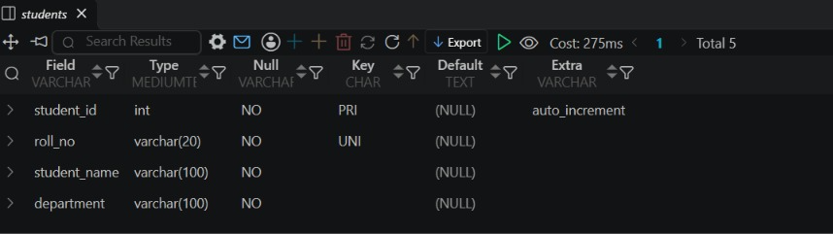
2. COURSES TABLE:
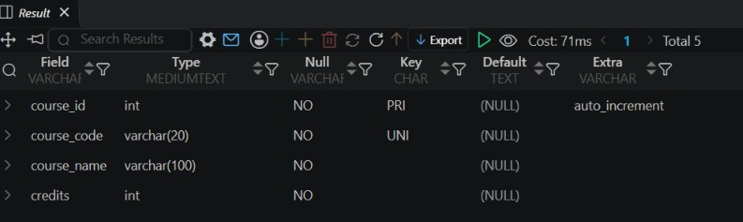
3. ENROLLMENTS TABLE:
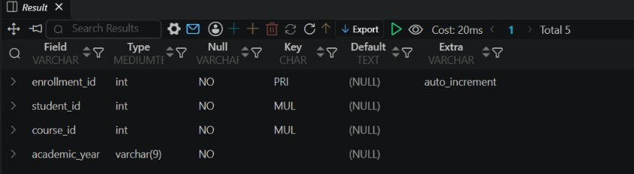
4. USERS TABLE:
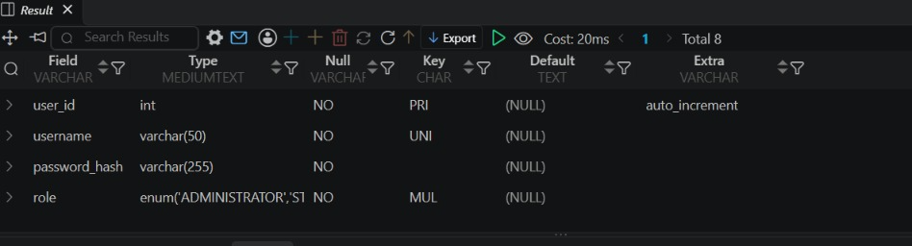
SOURCE CODE:
MAIN.JAVA (MENU AND DATABASE OPERATIONS):
case "2" -> addStudent(user);
case "3" -> listCourses();
case "4" -> attendance(user);
case "5" -> marks(user);
case "0" -> { System.out.println("Goodbye!"); return; }
default -> System.out.println("Invalid choice.");
}
} catch (Exception e) {
System.out.println("Operation failed: " + e.getMessage());
}
}
}
static void listStudents() throws SQLException {
String sql = "SELECT roll_no, student_name, department, semester " +
"FROM students ORDER BY roll_no";
try (Connection c = db(); Statement s = c.createStatement();
ResultSet r = s.executeQuery(sql)) {
System.out.printf("%-14s %-24s %-24s %s%n",
"Roll No", "Name", "Department", "Sem");
while (r.next())
System.out.printf("%-14s %-24s %-24s %d%n",
r.getString(1), r.getString(2), r.getString(3), r.getInt(4));
}
}
static void addStudent(UserSession u) throws SQLException {
if (u != null && u.isStudent()) {
System.out.println("Access denied."); return;
}
System.out.print("Roll number: ");
String roll = sc.nextLine().trim().toUpperCase();
System.out.print("Student name: ");
String name = sc.nextLine().trim();
System.out.print("Department: ");
String dept = sc.nextLine().trim();
System.out.print("Semester (1-8): ");
int sem = Integer.parseInt(sc.nextLine().trim());
if (roll.isEmpty() || name.isEmpty() || sem < 1 || sem > 8) {
System.out.println("Invalid student details."); return;
}
String sql = "INSERT INTO students(roll_no,student_name,department,semester) " +
"VALUES(?,?,?,?)";
try (Connection c = db(); PreparedStatement p = c.prepareStatement(sql)) {
p.setString(1, roll); p.setString(2, name);
p.setString(3, dept); p.setInt(4, sem);
p.executeUpdate();
System.out.println("Student registered.");
}
}
static void listCourses() throws SQLException {
String sql = "SELECT course_code, course_name, course_type, credits " +
"FROM courses ORDER BY course_code";
try (Connection c = db(); Statement s = c.createStatement();
ResultSet r = s.executeQuery(sql)) {
while (r.next())
System.out.printf("%s | %s | %s | %d credits%n",
r.getString(1), r.getString(2), r.getString(3), r.getInt(4));
}
}
static void attendance(UserSession u) throws SQLException {
if (u != null && u.isStudent()) {
System.out.println("Access denied."); return;
}
System.out.print("Enrollment ID: ");
int id = Integer.parseInt(sc.nextLine().trim());
System.out.print("Classes held: ");
int held = Integer.parseInt(sc.nextLine().trim());
System.out.print("Classes attended: ");
int attended = Integer.parseInt(sc.nextLine().trim());
if (held < 0 || attended < 0 || attended > held) {
System.out.println("Invalid attendance values."); return;
}
String sql = "INSERT INTO attendance(enrollment_id,classes_held," +
"classes_attended,condonation_approved) VALUES(?,?,?,0) " +
"ON DUPLICATE KEY UPDATE classes_held=VALUES(classes_held)," +
"classes_attended=VALUES(classes_attended)";
try (Connection c = db(); PreparedStatement p = c.prepareStatement(sql)) {
p.setInt(1, id); p.setInt(2, held); p.setInt(3, attended);
p.executeUpdate();
double pct = held == 0 ? 0 : attended * 100.0 / held;
System.out.printf("Attendance saved: %.1f%%%n", pct);
}
}
static void marks(UserSession u) throws SQLException {
if (u != null && u.isStudent()) {
System.out.println("Access denied."); return;
}
System.out.print("Enrollment ID: ");
int id = Integer.parseInt(sc.nextLine().trim());
String[] names = {"CIA1", "CIA2", "CIA3", "ESE"};
String find = "SELECT mark_id FROM assessment_marks " +
"WHERE enrollment_id=? AND assessment_name=?";
String update = "UPDATE assessment_marks SET marks_obtained=? WHERE mark_id=?";
String insert = "INSERT INTO assessment_marks(enrollment_id,assessment_name," +
"max_marks,marks_obtained,is_absent) VALUES(?,?,?,?,0)";
try (Connection c = db()) {
for (int i = 0; i < names.length; i++) {
System.out.print(names[i] + " marks: ");
double mark = Double.parseDouble(sc.nextLine().trim());
if (mark < 0 || mark > 100) {
System.out.println("Marks must be 0-100."); return;
}
Integer markId = null;
try (PreparedStatement p = c.prepareStatement(find)) {
p.setInt(1, id); p.setString(2, names[i]);
try (ResultSet r = p.executeQuery()) {
if (r.next()) markId = r.getInt(1);
}
}
try (PreparedStatement p = c.prepareStatement(
markId == null ? insert : update)) {
if (markId == null) {
p.setInt(1, id); p.setString(2, names[i]);
p.setDouble(3, 100); p.setDouble(4, mark);
p.setBoolean(5, false);
} else {
p.setDouble(1, mark); p.setInt(2, markId);
}
p.executeUpdate();
}
}
System.out.println("Marks saved.");
}
}

DATABASECONNECTION.JAVA:
import java.sql.Connection;
import java.sql.DriverManager;
import java.sql.SQLException;
public class DatabaseConnection {
// Default connection parameters
private static final String DEFAULT_DB_URL = "jdbc:mysql://127.0.0.1:3306/kec_academic";
private static final String DEFAULT_DB_USER = "root";
private static final String DEFAULT_DB_PASSWORD = " ";
public static String getDbUrl() {
String url = System.getenv("KEC_DB_URL");
return (url != null && !url.trim().isEmpty()) ? url.trim() : DEFAULT_DB_URL;
}
public static String getDbUser() {
String user = System.getenv("KEC_DB_USER");
return (user != null && !user.trim().isEmpty()) ? user.trim() : DEFAULT_DB_USER;
}
public static String getDbPassword() {
String pass = System.getenv("KEC_DB_PASSWORD");
return (pass != null) ? pass : DEFAULT_DB_PASSWORD;
}
/**
* Obtains a live JDBC Connection to the MySQL database.
*/
public static Connection getConnection() throws SQLException {
return DriverManager.getConnection(getDbUrl(), getDbUser(), getDbPassword());
}
}

JDBC CONNECTION DETAILS:
Property | Value
Database Host | 127.0.0.1 (localhost)
Port | 3306
Database Name | kec_academic
Username | root
Driver JAR | lib/mysql-connector-j-26.7.0.jar
JDBC Driver Class | com.mysql.cj.jdbc.Driver
OUTPUT SCREENSHOTS:
MAIN MENU:
1. MAIN MENU AND USER AUTHENTICATION:
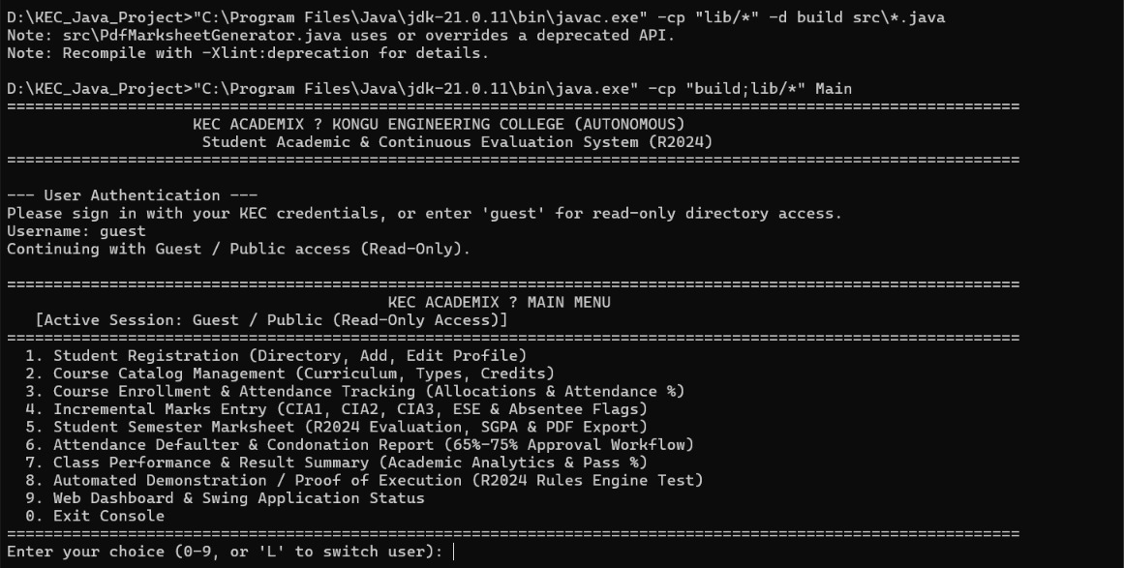
STUDENT & COURSE MANAGEMENT:
1. STUDENT REGISTRATION:
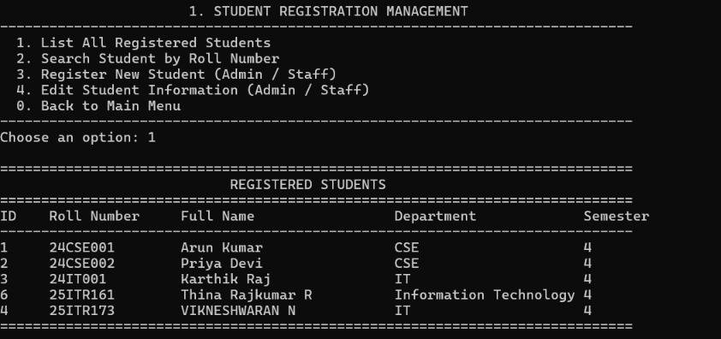
2. COURSE CATALOG:
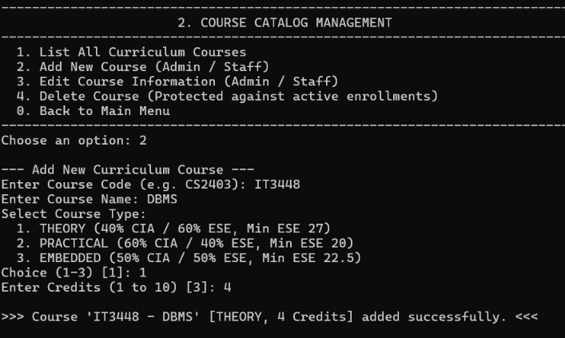
3. COURSE ENROLLMENT:
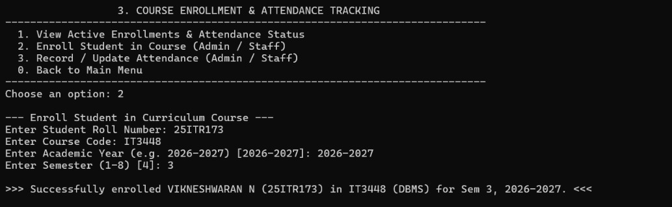
4. ATTENDANCE TRACKING:
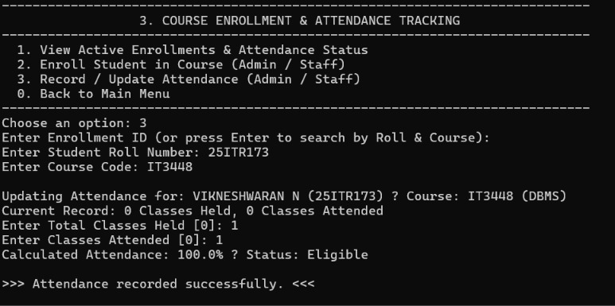
INCREMENTAL MARKS ENTRY:
1. CIA AND ESE MARKS ENTRY (R2024):
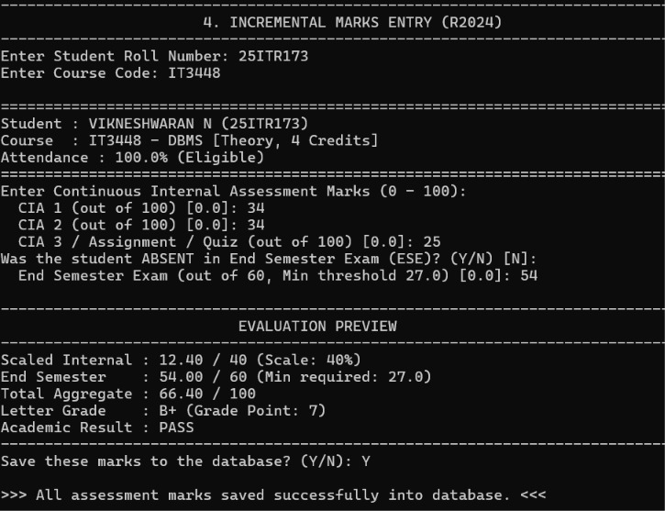
ATTENDANCE & GRADING RULES:
1. ATTENDANCE DEFAULTER AND CONDONATION REPORT:
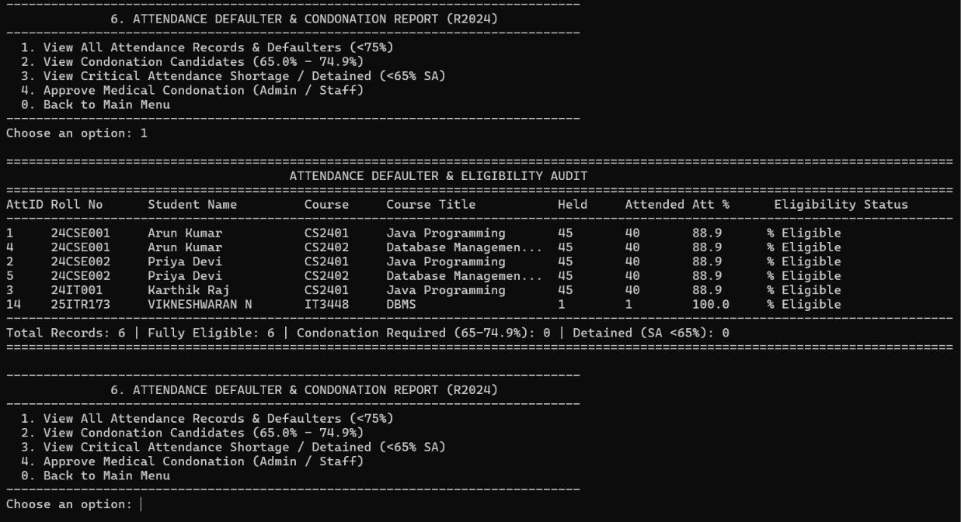
2. STUDENT SEMESTER MARKSHEET:
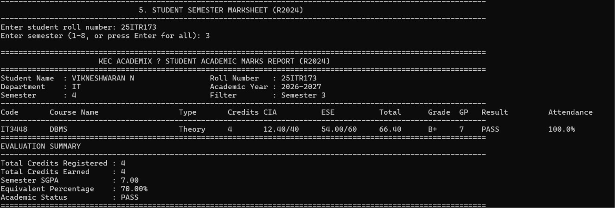
3. CLASS PERFORMANCE AND RESULT SUMMARY:
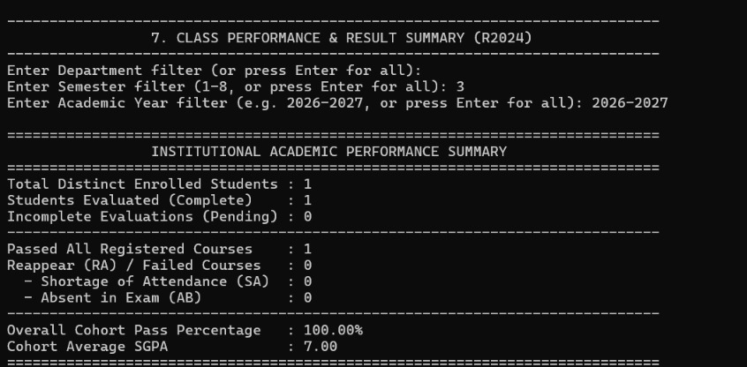
4. AUTOMATED DEMONSTRATION / PROOF OF EXECUTION:
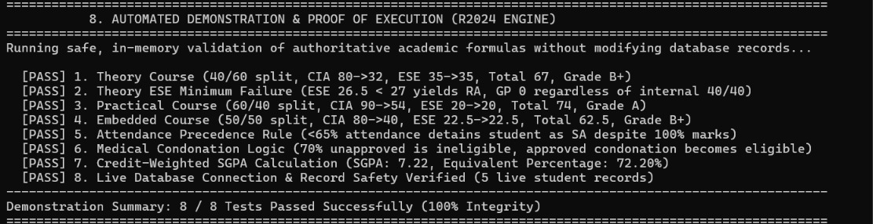
DATABASE:
STUDENTS, COURSES AND ENROLLMENTS TABLES (MySQL):
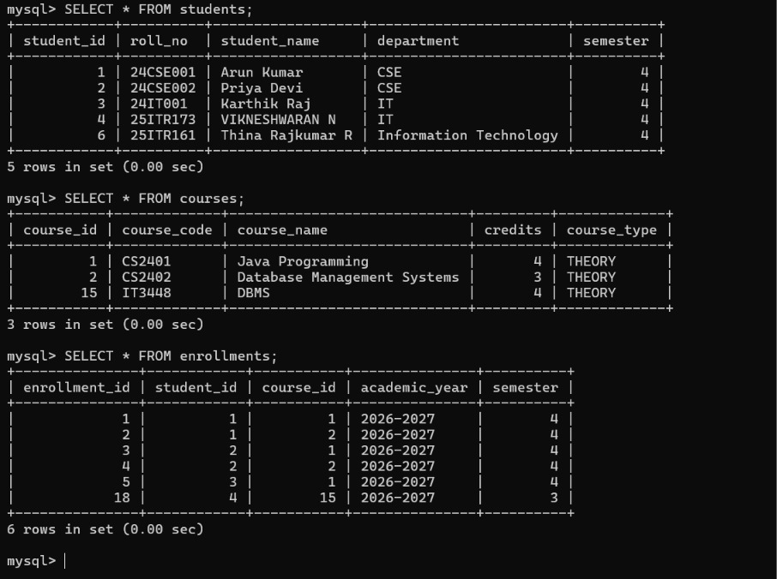

RESULT:
Thus, the Student Academic and Continuous Evaluation System for Kongu Engineering College (Autonomous) Regulation 2024 was successfully designed, developed, and tested using Java (JDBC) and MySQL. The application connected to the database successfully and automates attendance eligibility, Continuous Internal Assessment (CIA) and End Semester Examination (ESE) marks, letter grades and the Semester Grade Point Average (SGPA).

GITHUB | https://github.com/VikneshwaranNv/Java_JDBC_project

REFERENCES:
- Oracle, Java SE Documentation - JDBC Overview and Architecture. https://docs.oracle.com/javase/8/docs/technotes/guides/jdbc/

- Oracle, Java SE API Specification - java.sql Package. https://docs.oracle.com/en/java/javase/17/docs/api/java.sql/package-summary.html

3. Oracle, Java SE API - PreparedStatement. https://docs.oracle.com/en/java/javase/17/docs/api/java.sql/java/sql/PreparedStatement.

4. Oracle, MySQL 8.0 Reference Manual. https://dev.mysql.com/doc/refman/8.0/en/

5. Oracle, MySQL Connector/J Developer Guide. https://dev.mysql.com/doc/connector-j/8.0/en/

6. Oracle, Java Tutorials - JDBC Basics. https://docs.oracle.com/javase/tutorial/jdbc/basics/

